THORACIC WALL

05.03.2014

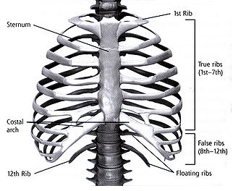

Kaan Yücel
M.D., Ph.D.
http://yeditepeanatomy.org
yeditepeanatomy@yahoo.com

THORACIC WALL
Thorax is the region between the neck and the abdomen. The terms chest and thorax are used interchangebly.
Thoracic wall: bounds the thoracic cavity which mainly includes the heart and the lungs. The throracic wall is formed by the skin, bones, fasciae, and muscles.
Thoracic cage: the bony portion of the thoracic wall, also known as thoracic skeleton.
Thoracic cavity: The cavity between neck and abdomen and is protected by the thoracic wall.
Skeleton of the thoracic wall is formed by by the 12 thoracic vertebræ and the posterior parts of the ribs posteriorly,
sternum and costal cartilages anteriorly and ribs, separated from each other by the intercostal spaces laterally.
The thorax includes the primary organs of the respiratory and cardiovascular systems.
The thorax is one of the most dynamic regions of the body. Although the joints between the bones of the thorax have limited movement ability, the whole outcome of these movements permits expansion of the cavity during inspiration. During inspiration, the thoracic cavity can expand in antero-posterior, vertical and transverse dimensions.
While the thoracic cage provides a complete wall peripherally, it is open superiorly and inferiorly; superior and inferior thoracic apertures.
Muscles of the thoracic wall are; serratus posterior, levator costarum, intercostal (external, internal and innermost), subcostal, and transverse thoracic. These muscles either elevate or depress the ribs helping to increse the volume of the thoracic cavity.
The arterial supply to the thoracic wall derives from the:
• Thoracic aorta, through the posterior intercostal and subcostal arteries.
• Subclavian artery, through the internal thoracic and supreme intercostal arteries.
• Axillary artery, through the superior and lateral thoracic arteries.
The intercostal veins accompany the intercostal arteries, nerves and lie most superior in the costal grooves (VAN).
The 12 pairs of thoracic spinal nerves supply the thoracic wall. 1st intercostal nerve, 2nd intercostal nerve, 7th-11th intercostal nerve and 12th intercostal nerve are considered as atypical intercostal nerves.
Breasts
The female breast rests on a bed that extends transversely from the lateral border of the sternum to the midaxillary line and vertically from the 2nd through 6th ribs.
A small part of the mammary gland may extend along the inferolateral edge of the pectoralis major toward the axillary fossa, forming an axillary process or tail (of Spence). The mammary gland is firmly attached to the dermis of the overlying skin, especially by the suspensory ligaments (of Cooper).
Most lymph (>75%), especially from the lateral breast quadrants, drains to the axillary lymph nodes, initially to the anterior or pectoral nodes for the most part. Most of the remaining lymph, particularly from the medial breast quadrants, drains to the parasternal lymph nodes or to the opposite breast, whereas lymph from the inferior quadrants may pass deeply to abdominal lymph nodes (subdiaphragmatic inferior phrenic lymph nodes).
- THORAX

The part between the neck and the abdomen is called thorax (Lat). The speculation on the terms “chest” and “thorax” exists though. In spite of the fact that the terms “chest” and “thorax” are used interchangeably, it is also said that the term “chest” is more extensive than the thorax and the thoracic cavity in it. These guys describe the chest as the superior part of the trunk that is broadest superiorly owing to the presence of the pectoral, or shoulder, girdle (clavicles and scapulae). The terms “chest” and “thorax”, however, might be used as synoynms in the daily clinical practice. We generally use the phrase “Chest X-ray” rather than “Thorax X-ray” when asking for the radiography of the area, but both images are the same, regardless of the terminology we use.
Whatever you see on the chest wall; muscles, bones, subcutaneous tissue, breast: forms the thoracic wall. The thoracic wall is covered on the outside by skin and by muscles attaching the shoulder girdle to the trunk. It is lined with parietal pleura. The skeleton is called the thoracic cage (skeleton), and the cavity in it is the thoracic cavity. The thoracic cavity has the shape of a truncated cone; narrowest superiorly, with the circumference increasing inferiorly, and reaching its maximum size at the junction with the abdominal portion of the trunk. The thoracic skeleton takes the form of a domed birdcage (see Figure 1). This cavity includes two vital organs; the heart and lungs. We can also define the thoracic wall as the space between the two apertures; the superior thoracic aperture and the inferior thoracic aperture.
1.1. REGIONS/TERMS
Thoracic cavity: the cavity between neck and abdomen and is protected by the thoracic wall.
Thoracic wall: bounded by the thoracic cavity & the diaphragm. The wall is formed by the skin, bones, fasciae, and muscles.
Thoracic cage: the bony portion of the thoracic wall, also known as thoracic skeleton
1.2. SURFACES OF THE THORAX
As the thoracic wall’s skeleton is formed by thoracic vertebrae posteriorly, sternum and costal cartilages anteriorly, and the ribs and intercostal spaces laterally, it is not difficult to compred its surfaces (Fig.1).
Posterior surface is formed by the 12 thoracic vertebræ and the posterior parts of the ribs.
Anterior surface is formed by the sternum and costal cartilages (blue in Fig.1).
Lateral surfaces are formed by the ribs, separated from each other by the intercostal spaces
The floor of the thoracic cavity (thoracic diaphragm) is deeply invaginated inferiorly (i.e., is pushed upward) by the organs of the abdominal cavity.

Figure 1. Thoracic cage (skeleton)
http://www.tutorvista.com/content/biology/biology-iv/locomotion-animals/thoracic-cage.php
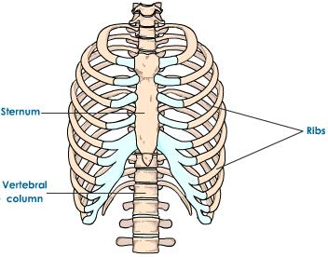
1.3. BOUNDARIES OF THE THORAX
Superior: jugular notch, sternoclavicular joint, superior border of clavicle, acromion, spinous processes of C7
Inferior: xiphoid process, costal arch, 12th and 11th ribs, vertebra T12
Figure 2. Boundaries of the thorax (the vertebrae are not demonstrated in the figure)
http://virtualhumanembryo.lsuhsc.edu/hs2412/laboratory/New_Lab_Guide/Thorax/Thorax_2.html
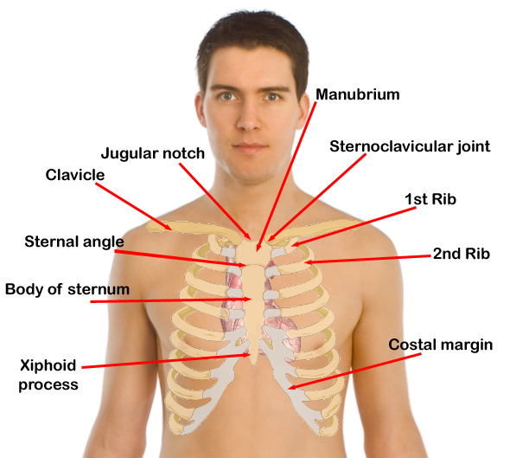

. 1.4. CONTENTS OF THE THORAX
(Organs of the cardiovascular, respiratory, digestive, reproductive, immune, and nervous systems)
The thorax includes the primary organs of the respiratory and cardiovascular systems. The majority of the thoracic cavity is occupied by the lungs, which provide for the exchange of oxygen and carbon dioxide between the air and blood. Most of the remainder of the thoracic cavity is occupied by the heart and structures involved in conducting the air and blood to and from the lungs. Additionally, nutrients (food) traverse the thoracic cavity via the esophagus, passing from the site of entry in the head to the site of digestion and absorption in the abdomen. Although in terms of function and development the mammary glands are most related to the reproductive system, the breasts are located on and are typically dissected with the thoracic wall. An organ of the immune system; thymus is also located in the thorax.
- T HORACIC WALL

The true thoracic wall includes the thoracic cage (skeleton) and the muscles that extend between the ribs as well as the skin, subcutaneous tissue, muscles, and fascia covering its anterolateral aspect. The mammary glands of the breasts lie within the subcutaneous tissue of the thoracic wall.

2.1.

Functions of the thoracic wall
The domed shape of the thoracic cage provides remarkable rigidity, given the light weight of its components, enabling it to:

- Protect vital thoracic and abdominal organs (most air or fluid filled) from external forces.

- Resist the negative (sub-atmospheric) internal pressures generated by the elastic recoil of the lungs and inspiratory movements.
- Provide attachment for and support the weight of the upper limbs.
- Provide the origins of many of the muscles that move and maintain the position of the upper limbs relative to the trunk.
3. Skeleton of THE Thoracic Wall

- Provide the attachments for muscles of the abdomen, neck, back, and respiration.

The thoracic skeleton includes:
- 12 pairs of ribs and associated costal cartilages
- 12 thoracic vertebrae and the intervertebral discs interposed between them
- Sternum
The ribs and costal cartilages form the largest part of the thoracic cage; both are identified numerically, from the most superior (1st rib or costal cartilage) to the most inferior (12th).
4. THORACIC APERTURES

While the thoracic cage provides a complete wall peripherally, it is open superiorly (communication with the root of the neck) and inferiorly (communication with the abdomen).
4.1. Superior thoracic aperture: The much smaller superior opening is a passageway that allows communication with the neck and upper limbs. The superior thoracic aperture is the “doorway” between
the thoracic cavity and the neck and upper limb.
The superior thoracic aperture is bounded:
- Posteriorly, by vertebra T1, the body of which protrudes anteriorly into the opening.
- Laterally, by the 1st pair of ribs and their costal cartilages.
- Anteriorly, by the superior border of the manubrium.
Structures that pass between the thoracic cavity and the neck through the oblique, kidney-shaped superior thoracic aperture include the trachea, esophagus, nerves, and vessels that supply and drain the head, neck, and upper limbs. Because of the obliquity of the 1st pair of ribs, the aperture slopes anteroinferiorly.
4.2. Inferior thoracic aperture: The larger inferior opening provides the ring-like origin of the diaphragm, which completely occludes the opening and separates the thoracic and abdominal cavities almost completely. Excursions of the diaphragm primarily control the volume/internal pressure of the thoracic cavity, providing the basis for tidal respiration (air exchange). The diaphragm protrudes upward so that upper abdominal viscera (e.g., liver) receive protection from the thoracic cage. Through this large opening, closed by the diaphragm, pass the esophagus and many large vessels and nerves, all of which pierce the diaphragm.
The inferior thoracic aperture, the anatomical thoracic outlet, is bounded as follows:
- Posteriorly, by the 12th thoracic vertebra, the body of which protrudes anteriorly into the opening.
- Posterolaterally, by the 11th and 12th pairs of ribs.
- Anterolaterally, by the joined costal cartilages of ribs 7-10, forming the costal margins.
- Anteriorly, by the xiphisternal joint.
Figure 10. Superior and inferior thoracic apertures
http://quizlet.com/4653983/2-thorax-i-flash-cards/
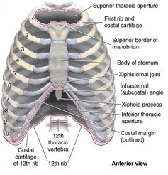
CLINICAL ANATOMY

Thoracic Outlet Syndrome (TOS): Anatomists refer to the superior thoracic aperture as the thoracic inlet because non-circulating substances (air and food) may enter the thorax only through this aperture. When clinicians refer to the superior thoracic aperture as the thoracic outlet, they are emphasizing the arteries and T1 spinal nerves that emerge from the thorax through this aperture to enter the lower neck and upper

limbs. The brachial plexus of nerves and the subclavian artery and vein are closely related to the upper surface of the first rib and the clavicle as they enter the upper limb. It is here that the nerves or blood vessels may be compressed between the bones. Most of the symptoms are caused by pressure on the lower trunk of the plexus producing pain down the medial side of the forearm and hand and wasting of the small muscles of the hand. Pressure on the blood vessels may compromise the circulation of the upper limb.
5. JOINTS OF the THORACIC WALL

Although the joints between the bones of the thorax have limited movement ability, the whole outcome of these movements permits expansion of the cavity during inspiration. During inspiration, the thoracic cavity can expand in antero-posterior, vertical and transverse dimensions.
Together, the costovertebral joints and related ligaments allow the necks of the ribs either to rotate around their longitudinal axes, which occur mainly in the upper ribs, or to ascend and descend relative to the vertebral column, which occurs mainly in the lower ribs. The combined movements of all of the ribs on the vertebral column are essential for altering the volume of the thoracic cavity during breathing.
1. Costotransverse joints: synovial joints between the tubercle of a rib and the transverse process of the related vertebra. Slight gliding movements occur at the costotransverse joints.
2. Sternocostal joint: between the upper seven costal cartilages and the sternum
3. Costachondralis joint: between the rib and costal cartilage.
4. Intercondral joints: Synovial joints between the costal cartilages of 6th and 7th, 7th and 8th, and 8th and 9th ribs.The joint between the 9th and 10th is never synovial and can be absent.
5. Sternal Joints: between the Manubrium, body, xiphoid process of the sternum.
5. JOI
6. Muscles of the Thoracic Wall

Muscles of the thoracic wall include those that fill and support the intercostal spaces, those that pass between the sternum and the ribs, and those that cross several ribs between costal attachments. The muscles of the thoracic wall, together with muscles between the vertebrae and ribs posteriorly (i.e., the levatores costarum, and serratus posterior superior and serratus posterior inferior muscles) alter the position of the ribs and sternum and so change thoracic volume during breathing. They also reinforce the thoracic wall. Some muscles attached to and/or covering the thoracic cage are primarily involved in serving other regions. Several (axioappendicular) muscles extend from the thoracic cage (axial skeleton) to bones of the upper limb (appendicular skeleton). Similarly, some muscles of the anterolateral abdominal wall, back, and neck muscles have attachments to the thoracic cage.
Muscles of the thoracic wall
- Serratus posterior muscles
- Levator costarum muscles
- Intercostal muscles(External, internal and innermost)
- Subcostal muscle
- Transverse thoracic muscle

These muscles either elevate or depress the ribs helping to increse the volume of the thoracic cavity.
Table 1. Muscles of the thoracic wall: their origins, insertions, nerves and functions.
Muscle(s) | Origin | Insertion | Nerve | Function
Serratus posterior superior | Ligamentum nuchae, spinous processes of C7-T3 vertebrae | Superior borders of 2nd to 5th ribs | 2nd-5th intercostal nerves | Elevate ribs 2nd-5th
Serratus posterior inferior | Spinous processes of T11-L2 vertebrae | Inferior borders of 9th to 12th ribs | 9th-12th intercostal nerves | Depress ribs 9th-12th
Levator costarum muscles | Transverse processes of C7-T11 vertebrae | Tubercle and angle of the rib below | Dorsal primary rami of C8-T11 spinal nerves | Elevate ribs
External intercostal | Inferior borders of the ribs | Superior borders of the ribs below | Intercostal nerves | Elevate the ribs; Most active during inspiration; supports intercostal space; moves ribs superiorly
Internal intercostal | Inferior borders of the ribs | Superior borders of the ribs below | Intercostal nerves | Elevate (interchondral part) and depress (interosseous part) the ribs; Most active during expiration; supports intercostal space; moves ribs inferiorly
Innermost intercostal | Inferior borders of the ribs | Superior borders of the ribs below | Intercostal nerves | Similar to the internal intercostal muscles
Subcostal | Internal surface of the lower ribs | Internal surface of the lower ribs | Intercostal nerves | Elevate ribs
Transversus thoracis | Posterior surface of lower sternum | Internal surface of costal cartilages 2nd-6th | Intercostal nerves | Weakly depress ribs  Proprioception?
The intercostal muscles are three flat muscles found in each intercostal space that pass between adjacent ribs. Individual muscles in this group are named according to their positions: external intercostal muscles are the most superficial; internal intercostal muscles are sandwiched between the external and innermost muscles.
The eleven pairs of external intercostal muscles extend from the inferior margins (lateral edges of costal grooves) of the ribs above to the superior margins of the ribs below. When the thoracic wall is viewed from a lateral position, the muscle fibers pass obliquely anteroinferiorly.
The eleven pairs of internal intercostal muscles pass between the most inferior lateral edges of the costal grooves of the ribs above, to the superior margins of the ribs below. The muscle fibers pass in the opposite direction to those of the external intercostal muscles. When the thoracic wall is viewed from a lateral position, the muscle fibers pass obliquely posteroinferiorly. The internal intercostal muscles are most active during expiration. (Note: I for inspiration, E for expiration, just the opposite for the muscles; Internal and External intercostal muscles). The interchondral parts of the internal intercostal muscles elevate the ribs, whereas the interosseous parts of the ribs are depressed by the intercostal muscles. The same pattern is also for the innermost intercostal muscles. The parts of these muscles attached to cartilages do not move during expiration.
The innermost intercostal muscles are the least distinct of the intercostal muscles, and the fibers have the same orientation as the internal intercostals. The neurovascular bundles associated with the intercostal spaces pass around the thoracic wall in the costal grooves in a plane between the innermost and internal intercostal muscles.
The transversus thoracis muscles are found on the deep surface of the anterior thoracic wall and in the same plane as the innermost intercostals. They lie deep to the internal thoracic vessels and secure these vessels to the wall.
The subcostales are in the same plane as the innermost intercostals, span multiple ribs, and are more numerous in lower regions of the posterior thoracic wall. Their fibers parallel the course of the internal intercostal muscles and extend from the angle of the ribs to more medial positions on the ribs below.
The diaphragm is a shared wall (actually floor/ceiling) separating the thorax and abdomen. Although it has functions related to both compartments of the trunk, its most important (vital) function is serving as the primary muscle of inspiration.
6.1. Accessory muscles of respiration
The movement of the diaphragm alone is sufficient for normal and quiet breathing.Extra pyhsicial exercise (Usain Bolt while breaking a world record, or someone running to catch a public bus; when you need extra energy in a short time; as in stress response ) and pulmonary disesases (with difficulty in breathing; dyspnea) increases the work of breathing. Under these conditions one needs extra muscles; accessory muscles to work in order to breathe properly. The upper accessory muscles assist with inspiration; and the upper chest, and abdominal muscles assist with expiration.
Figure 11. Muscles of the thoracic wall
http://by411.blogspot.com/2011/03/breathing.html
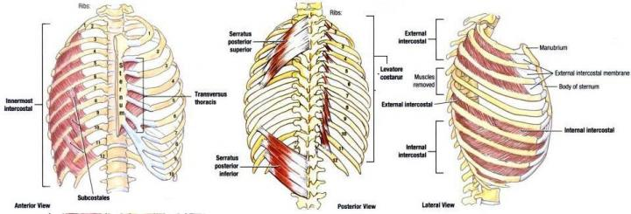
7. MOVEMENTS OF the THORACIC WALL

One of the principal functions of the thoracic wall and the diaphragm is to alter the volume of the thorax and thereby move air in and out of the lungs.
During breathing, the dimensions of the thorax change in the vertical, lateral, and anteroposterior directions. Elevation and depression of the diaphragm significantly alter the vertical dimensions of the thorax. Depression results when the muscle fibers of the diaphragm contract. Elevation occurs when the diaphragm relaxes.
During passive expiration, the diaphragm, intercostal muscles, and other muscles relax, decreasing intrathoracic volume and increasing the intrathoracic pressure. Concurrently, intra-abdominal pressure decreases and abdominal viscera are decompressed. This allows the stretched elastic tissue of the lungs to recoil, expelling most of the air. Changes in the anteroposterior and lateral dimensions result from elevation and depression of the ribs. The posterior ends of the ribs articulate with the vertebral column, whereas the anterior ends of most ribs articulate with the sternum or adjacent ribs.
The combination of all the movements moves the thoracic cage anteriorly, superiorly, and laterally.
Figure 12. Movements of the thoracic wall
http://www.studydroid.com/index.php?page=studyPack&packId=9240

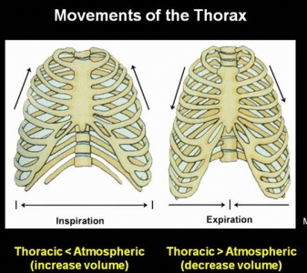
8. FASCIAe OF the THORACIC WALL

Each part of the deep fascia is named for the muscle it invests or for the structure(s) to which it is attached. Consequently, a large portion of the deep fascia overlying the anterior thoracic wall is called pectoral fascia for its association with the pectoralis major muscles. In turn, much of the pectoral fascia forms a major part of the bed of the breast (structures against which the posterior surface of the breast lies). The thoracic cage is lined internally with endothoracic fascia. The endotracic fascia is a thin layer of loose connective tissue that separates the parietal pleura from the thoracic wall.
Figure 13. Endothoracic fascia
http://www.joacp.org/article.asp?issn=0970-9185;year=2011;volume=27;issue=1;spage=5;epage=11;aulast=Batra
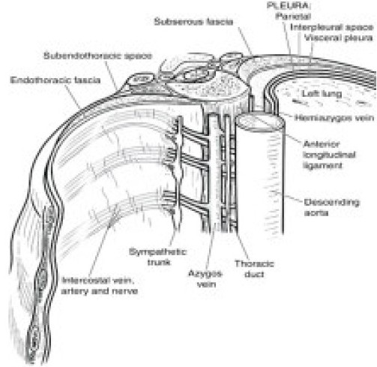
9. VASCULATURE OF the THORACIC WALL

In general, the pattern of vascular distribution in the thoracic wall reflects the structure of the thoracic cage. Vessels that supply the thoracic wall consist mainly of posterior and anterior intercostal arteries, which pass around the wall between adjacent ribs in intercostal spaces.
9.1. Arteries of THE Thoracic Wall
The arterial supply to the thoracic wall derives from the:
- Thoracic aorta, through the posterior intercostal and subcostal arteries.
- Subclavian artery, through the internal thoracic and supreme intercostal arteries.
- Axillary artery, through the superior and lateral thoracic arteries.
The intercostal arteries course through the thoracic wall between the ribs. With the exception of the 10th and 11th intercostal spaces, each intercostal space is supplied by three arteries: a large posterior intercostal artery and a small pair of anterior intercostal arteries.
The anterior intercostal arteries originate directly or indirectly as lateral branches from the internal thoracic arteries. The internal thoracic artery is the very first branch of the subclavian artery.
9.2. Veins of THE Thoracic Wall
The intercostal veins accompany the intercostal arteries and nerves and lie most superior in the costal grooves. There are 11 posterior intercostal veins and one subcostal vein on each side. The posterior intercostal veins anastomose with the anterior intercostal veins (tributaries of internal thoracic veins).
10. NERVES OF the THORACIC WALL

Innervation of the thoracic wall is mainly by the 12 pairs of intercostal nerves, which are the anterior rami of spinal nerves T1 to T11 and lie in the intercostal spaces between adjacent ribs. The anterior ramus of spinal nerve T12 (the subcostal nerve) is inferior to rib XII.
11. breasts

The breasts are the most prominent superficial structures in the anterior thoracic wall, especially in women. The breasts are important for three concepts; reproduction, back pain, aesthetics, and breast cancer.
The breasts consist of mammary glands and associated skin and connective tissues. The mammary glands are modified sweat glands in the superficial fascia anterior to the pectoral muscles and the anterior thoracic wall. The mammary glands consist of a series of ducts and associated secretory lobules. These converge to form 15 to 20 lactiferous ducts, which open independently onto the nipple. The nipple is surrounded by a circular pigmented area of skin termed the areola (L. small area).
The mammary glands within the breasts are accessory to reproduction in women. They are rudimentary and functionless in men, consisting of only a few small ducts or epithelial cords.
11.1. Female Breasts
The amount of fat surrounding the glandular tissue determines the size of non-lactating breasts. In nonlactating women, the predominant component of the breasts is fat, while glandular tissue is more abundant in lactating women.The roughly circular body of the female breast rests on a bed that extends transversely from the lateral border of the sternum to the mid-axillary line and vertically from the 2nd through 6th ribs.

Figure 15. Internal structure of the breast
http://anthingblissful.blogspot.com/2006/04/anatomy-of-human-breast.html
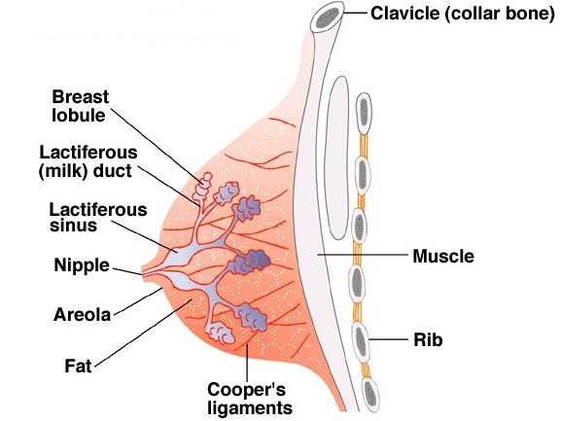
The mammary gland is firmly attached to the dermis of the overlying skin, especially by substantial skin ligaments (L. retinacula cutis), the suspensory ligaments (of Cooper). These condensations of fibrous connective tissue, particularly well developed in the superior part of the gland, help support the lobes and lobules of the mammary gland.

A small part of the mammary gland may extend along the inferolateral edge of the pectoralis major toward the axillary fossa (armpit), forming an axillary process or tail (of Spence). Some women discover this (especially when it may enlarge during a menstrual cycle) and become concerned that it may be a lump (tumor) or enlarged lymph nodes.
The arterial supply of the breast:
- Medial mammary branches (from perforating and ant. intercostal branches of the internal thoracic artery originating from the subclavian artery)
2. Lateral mammary branches, lateral thoracic and thoracoacromial arteries (from axillary artery)
3. Posterior intercostal arteries 2nd-4th (from aorta)
The venous drainage of the breast is mainly to the axillary vein, but there is some drainage to the internal thoracic vein and intercostal veins.
The lymphatic drainage of the breast is important because of its role in the metastasis of cancer cells. Lymph passes from the nipple, areola, and lobules of the gland to the subareolar lymphatic plexus.
Lymphatic drainage of the breast is as follows:
- 75%, especially from the lateral breast quadrants, is via lymphatic vessels that drain into axillary lymph nodes (apical, humeral/lateral, central, pectoral/anterior, subscapular/posterior lymph nodes). The drainage is initially to the anterior or pectoral nodes for the most part. However, some lymph may drain directly to other axillary nodes or even to interpectoral, deltopectoral, supraclavicular, or inferior deep cervical nodes.
- Most of the remaining drainage, particularly from the medial breast quadrants, is into parasternal nodes deep to the anterior thoracic wall and associated with the internal thoracic artery, whereas lymph from the inferior quadrants may pass deeply to abdominal lymph nodes (subdiaphragmatic inferior phrenic lymph nodes).
- Some drainage may occur via lymphatic vessels that follow the lateral branches of posterior intercostal arteries and connect with intercostal nodes situated near the heads and necks of ribs.
Lymph from the axillary nodes drains into clavicular (infraclavicular and supraclavicular) lymph nodes and from them into the subclavian lymphatic trunk. Lymph from the parasternal nodes enters the bronchomediastinal lymphatic trunks. In many (perhaps most) cases, the trunks open independently into the junction of the internal jugular and subclavian veins, the right or left venous angles, that form the right and left brachiocephalic veins. In some cases, they open into both of these veins.
Innervation of the breast is via anterior and lateral cutaneous branches of the second to sixth intercostal nerves. The nipple is innervated by the fourth intercostal nerve. The branches of the intercostal nerves convey sensory fibers from the skin of the breast and sympathetic fibers to the blood vessels in the breasts and smooth muscle in the overlying skin and nipple.
Figures 16. Lymphatic drainage of the breast
http://ourhumananatomy.blogspot.com/2008/08/19-breast-lymphatic-drainage.html http://www.breastdiseases.com/anat.htm
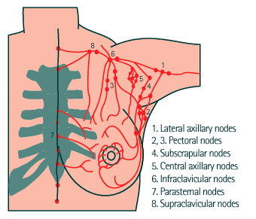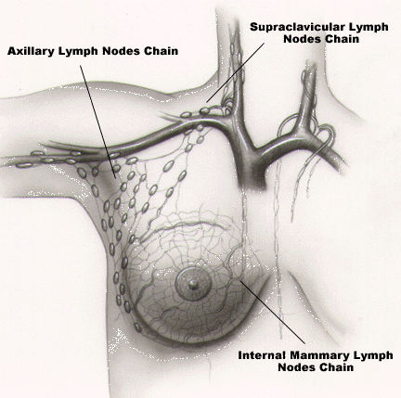
CLINICAL ANATOMY
Breast Quadrants: For the anatomical location and description of tumors and cysts, the surface of the breast is divided into four quadrants (See Fig.17).
Breast Cancer: Breast cancer is the most common cancer among women, other than skin cancer, and is the second leading cause of cancer death in women, after lung cancer. The chance of a woman having invasive breast cancer some time during her life is about 1 in 8 with a chance of dying from breast cancer about 1 in 33. It’s estimated that $8.1 billion is spent annually on breast cancer management in the United States.
Understanding the lymphatic drainage of the breasts is of practical importance in predicting the metastasis (dispersal) of cancer cells from a carcinoma of the breast (breast cancer).
Breast self examinations should start in women at age 20, and clinical breast examinations should be
included in routine health examinations; about every 3 years for women in their 20s and 30s, and every year for women older than 40. Approximately 60% of carcinomas of the breast occur in the upper lateral quadrant.
Breast cancer typically spreads by means of lymphatic vessels (lymphogenic metastasis), which carry cancer cells from the breast to the lymph nodes, chiefly those in the axilla. Determination of axillary lymph node involvement in breast cancer is important in terms of treatment protocols, follow-up and prediction of prognosis (Duzgun et al, 2011). Regional lymph nodes are usually the first metastatic sites to be involved, often followed by distant metastasis to the lungs, liver and bones. Although various prognostic factors are known, regional lymph node status is the single most important prognostic factor in breast cancer; patients with axillary metastasis at the time of diagnosis have a much worse prognosis than those without metastasis (Giles et al, 2008).
Because most of lymphatic drainage of the breast is to the axillary lymph nodes, they are the most common site of metastasis from a breast cancer. Enlargement of these palpable nodes suggests the possibility of breast cancer and may be key to early detection. However, the absence of enlarged axillary lymph nodes is no guarantee that metastasis from a breast cancer has not occurred because the malignant cells may have passed to other nodes, such as the infraclavicular and supraclavicular lymph nodes.
Mammography: The mainstay of early breast cancer detection is the use of mammography. The ACS recommends annual screening with mammography for any woman older than 40 (ACS, 2007). Digital mammograms are slowly replacing conventional film mammography, whereby younger women with dense breast tissue benefit most from this type of mammography. A carcinoma appears as a large, jagged density in the mammogram. The skin is thickened over the tumor and the nipple is depressed. Surgeons use mammography as a guide when removing breast tumors, cysts, and abscesses.
Mastectomy: Mastectomy (breast excision) is not as common as it once was as a treatment for breast cancer. In simple mastectomy, the breast is removed down to the retromammary space. Radical mastectomy, a more extensive surgical procedure, involves removal of the breast, pectoral muscles, fat, fascia, and as many lymph nodes as possible in the axilla and pectoral region.
Polymastia, Polythelia, and Amastia
Polymastia (supernumerary breasts) or polythelia (accessory nipples) may occur superior or inferior to the normal pair, occasionally developing in the axillary fossa or anterior abdominal wall. Supernumerary breasts usually consist of only a rudimentary nipple and areola, which may be mistaken for a mole (nevus) until they change pigmentation with the normal nipples during pregnancy. However, glandular tissue may also be present and further develop with lactation. Extra breasts may appear anywhere along a line extending from the axilla to the groin—the location of the embryonic mammary crest (milk line) from which the breasts develop. There may be no breast development (amastia), or there may be a nipple and/or areola, but no glandular tissue.

Figure 17. Breast quadrants
http://training.seer.cancer.gov/breast/anatomy/quadrants.html
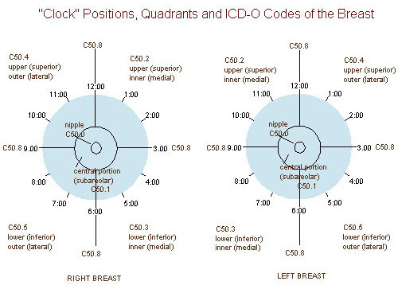
The upper quadrant is the most common site of origin of the breast cancer. The breast cancer is more common in the left breast than in the right one.
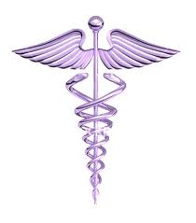

- B.C. is a 42 year old woman who is in the premenapousal period.
- One morning she noticed a lump, at the size of a walnut, on the left breast at 11 o’clock position.
- There was redness and swelling of the breast skin over the lump.
- She had a visit to her family doctor that afternoon.
- She was referred to a general surgeon in downtown and had an appointment for two days later.
- The general surgeon took her anamnesis/history and gave her a full medical examination.
- After a careful examination, the general surgeon has learned that she was also suffering from lower back pain.
- The general surgeon asked for blood tests, mammogram, abdomen CT (computed tomography), bone scintigraphy, and biopsy from the lump.
Case Questions
Q1: To which lymp nodes would you expect to have metastasis of the breast cancer as the physician of B.C.?
Q2: At which stage is B.C.’s breast cancer?
Q3: What is the best surgical procedure?

OR
1. PECTAL REGION

The pectoral region is external to the anterior thoracic wall and anchors the upper limb to the trunk. It consists of:
•a superficial compartment containing skin, superficial fascia, and breasts; and
•a deep compartment containing muscles and associated structures.
Nerves, vessels, and lymphatics in the superficial compartment emerge from the thoracic wall, the axilla, and the neck.
2. MUSCLES OF THE PECTORAL REGION

Four anterior axioappendicular muscles (thoracoappendicular or pectoral muscles) move the pectoral girdle: pectoralis major, pectoralis minor, subclavius, and serratus anterior. The pectoralis major, pectoralis minor, and subclavius muscles originate from the anterior thoracic wall and insert into bones of the upper limb; and the serratus anterior to the scapula.

The pectoralis major muscle is the largest and most superficial of the pectoral region muscles It is a large, fan-shaped muscle that covers the superior part of the thorax. It directly underlies the breast.
Pectoralis major has clavicular and sternocostal heads. The sternocostal head is much larger, and its lateral border forms the muscular mass that makes up most of the anterior wall of the axilla. Its inferior border forms the anterior axillary fold.
The pectoralis major and adjacent deltoid muscles form the narrow deltopectoral groove, in which the cephalic vein runs. Producing powerful adduction and medial rotation of the arm when acting together, the two parts of the pectoralis major can also act independently: the clavicular head flexing the humerus, and the sternocostal head extending it back from the flexed position.
ORIGIN INSERTION
Figure 1. Pectoralis major
Pectoralis major | Clavicular head: Medial half of clavicle  Sternocostal head:  - Anterior surface of sternum  - Superior six costal cartilages  - Aponeurosis of external oblique muscle | Lateral lip of intertubercular sulcus of humerus
http://www.frozenshoulder.ca/anatomy.html
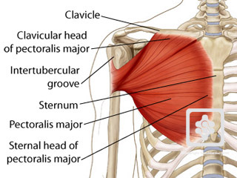

The subclavius and pectoralis minor muscles underlie pectoralis major. Both subclavius and pectoralis minor pull the tip of the shoulder inferiorly.

Figure 2. Pectoralis minor and subclavius
http://www.massagetherapy.com/ce/content/images/145.jpg
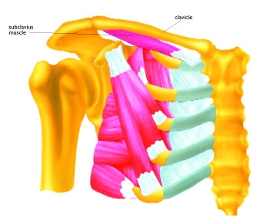

The serratus anterior overlies the lateral part of the thorax and forms the medial wall of the axilla. This broad sheet of thick muscle was named because of the saw-toothed appearance of its fleshy slips or digitations (L. serratus, a saw). The serratus anterior is one of the most powerful muscles of the pectoral girdle. It is a strong protractor of the scapula and is used when punching or reaching anteriorly (sometimes called the “boxer's muscle”). The strong inferior part of the serratus anterior rotates the scapula, elevating its glenoid cavity so the arm can be raised above the shoulder. It also anchors the scapula, keeping it closely applied to the thoracic wall, enabling other muscles to use it as a fixed bone for movements of the humerus. The serratus anterior holds the scapula against the thoracic wall when doing push-ups or when pushing against resistance (e.g., pushing a car).
Figure 3. Serratus anterior
http://www.nickcampos.com/2011/10/serratus-anterior-exercises-for-shoulder-pain-relief
Serratus anterior | Lateral parts of 1st-8th ribs | Medial border of scapula
ORIGIN INSERTION
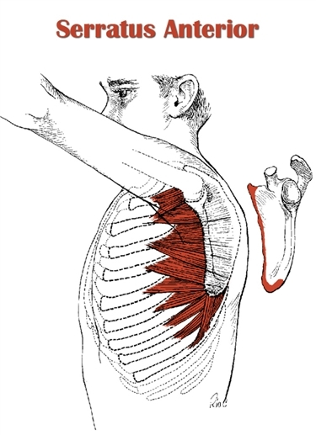
3. fascıae of the pectoral regıon

The fascia of the pectoral region is attached to the clavicle and sternum. The pectoral fascia invests the pectoralis major and is continuous inferiorly with the fascia of the anterior abdominal wall. The pectoral fascia leaves the lateral border of the pectoralis major and becomes the axillary fascia, which forms the floor of the axilla.
Clavipectoral fascia
Deep to the pectoral fascia and the pectoralis major, another fascial layer, the clavipectoral fascia, descends from the clavicle, enclosing the subclavius and then the pectoralis minor, becoming continuous inferiorly with the axillary fascia. Nerves, vessels, and lymphatics that pass between the pectoral region and the axilla pass through the clavipectoral fascia between subclavius and pectoralis minor or pass under the inferior margins of pectoralis major and minor.
The part of the clavipectoral fascia between the pectoralis minor and the subclavius, the costocoracoid membrane, is pierced by the lateral pectoral nerve, which primarily supplies the pectoralis major. The part of the clavipectoral fascia inferior to the pectoralis minor, the suspensory ligament of the axilla, supports the axillary fascia and pulls it and the skin inferior to it upward during abduction of the arm, forming the axillary fossa.
The clavipectoral triangle (deltopectoral triangle) is the area in the pectoral region where the cephalic vein can be found. The triangle is formed by the pectoralis major, deltoid and the clavicle. The deltopectoral groove is an indentation in the muscular structure between the deltoid muscle and pectoralis major. It is the location through which the cephalic vein passes and where the coracoid process is most easily palpable.
Figure 4. Clavipectoral fascia
http://www.scielo.cl/scielo.php?pid=s0717-95022006000500030&script=sci_arttext
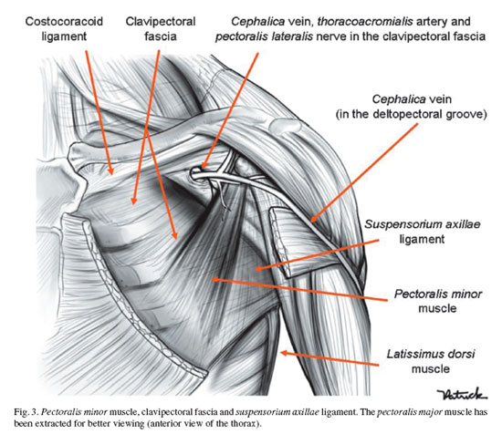

Table. Muscles of the pectoral region
Muscle | Proximal Attachment (Origin) | Distal Attachment (Insertion) | Innervation^{X} | Main Action
Pectoralis major | Clavicular head: Medial half of clavicle  Sternocostal head:  - Anterior surface of sternum  - Superior six costal cartilages  - Aponeurosis of external oblique muscle | Lateral lip of intertubercular sulcus of humerus | Lateral and medial pectoral nerves; clavicular head (C5, C6), sternocostal head (C7, C8, T1) | Adducts, flexes, and medially rotates the arm.  Acting alone, clavicular head flexes humerus and sternocostal head extends it from the flexed position
Pectoralis minor | 3rd-5th ribs near their costal cartilages | Coracoid process of scapula | Medial pectoral nerve (C8, T1) | Stabilizes scapula by drawing it inferiorly and anteriorly against thoracic wall
Subclavius | Junction of 1st rib and its costal cartilage | Inferior surface of middle third of clavicle | Nerve to subclavius (C5, C6) | Anchors and depresses clavicle
Serratus anterior | Lateral parts of 1st-8th ribs | Medial border of scapula | Long thoracic nerve (C5, C6, C7) | Protracts scapula and holds it against thoracic wall; rotates scapula
X The spinal cord segmental innervation is indicated (e.g., “C5, C6” means that the nerves supplying the subclavius are derived from the fifth and sixth cervical segments of the spinal cord). Numbers in boldface (C5) indicate the main segmental innervation. Damage to one or more of the listed spinal cord segments or to the motor nerve roots arising from them results in paralysis of the muscles concerned.

